1

Previous Model:

class Recipe(models.Model):
name = models.CharField(max_length=50)
ingredients = models.CharField(max_length=255)
cooking_time = models.IntegerField()
difficulty = models.CharField(max_length=20)

def __str__(self):
return f"Recipe ID: {self.id} – {self.name}"

Updated Model:
class Recipe(models.Model):
name = models.CharField(max_length=50)
ingredients = models.CharField(max_length=255)
cooking_time = models.IntegerField()
difficulty = models.CharField(max_length=20)
directions = models.TextField(max_length=1000, default="")
image = models.ImageField(upload_to='recipe_images', default='no_picture.jpg')

def __str__(self):
return f"Recipe ID: {self.id} - {self.name}"

I updated the model to include 'directions' and 'image', because each recipe should include a picture and the directions on how to actually cook the recipe.
There a almost countless additions (ratings, created by, upload date...) we could make to the recipe model and also add other models, but I guess that would be out of the scope of this exercise.

2
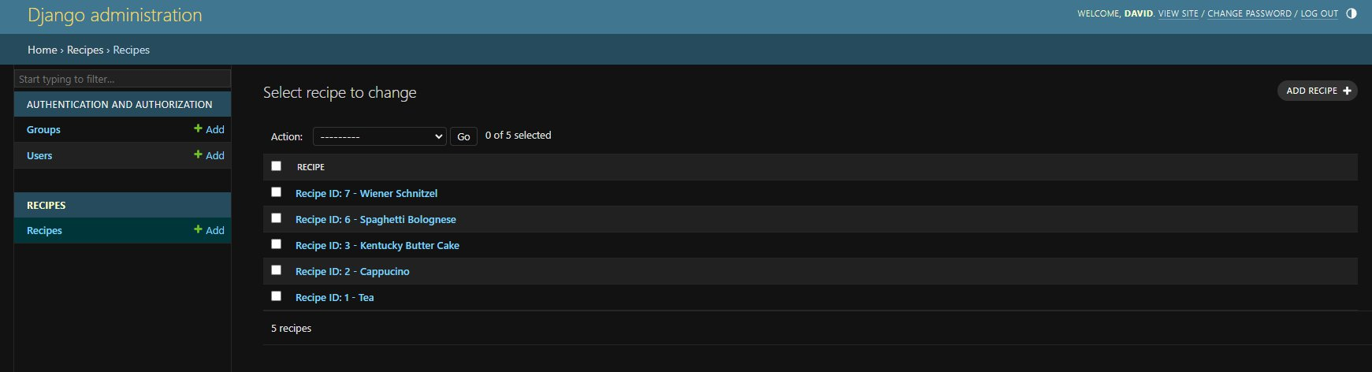
3

https://www.allrecipes.com/
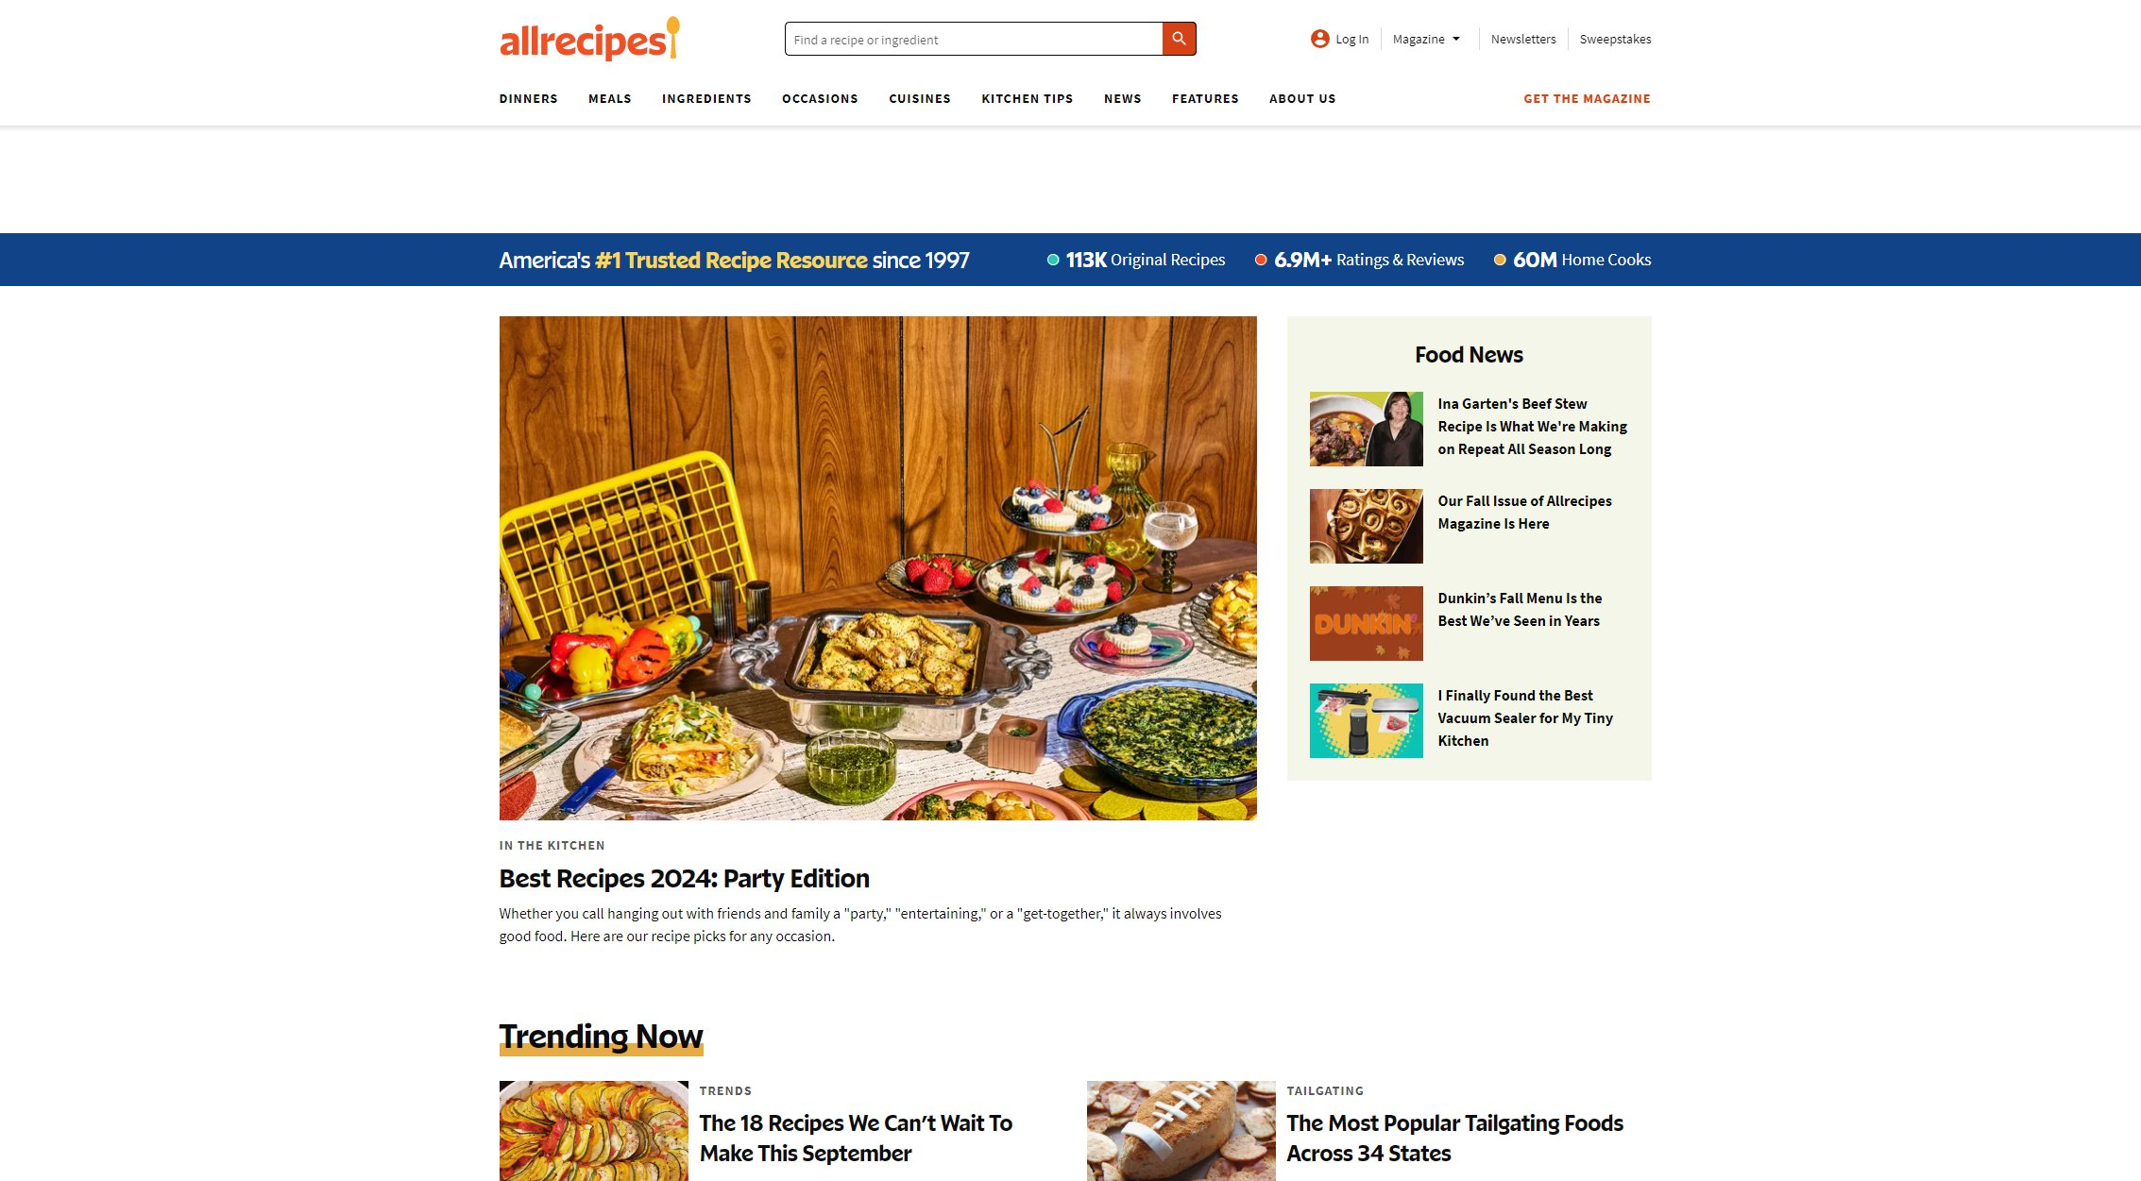

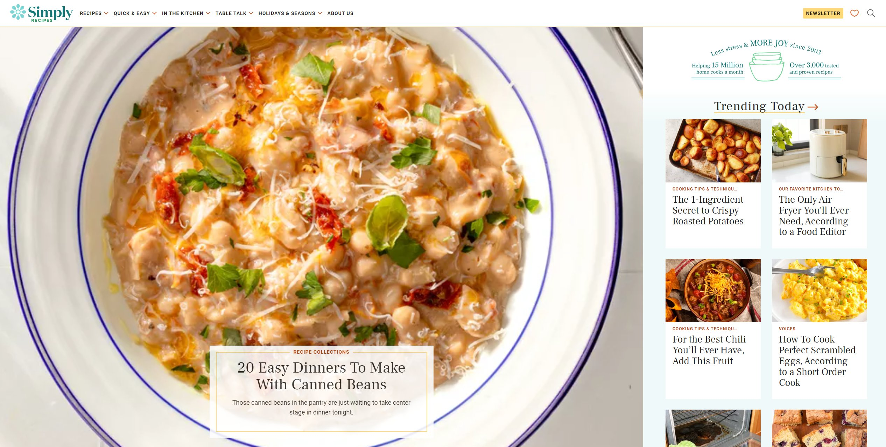
https://www.simplyrecipes.com/

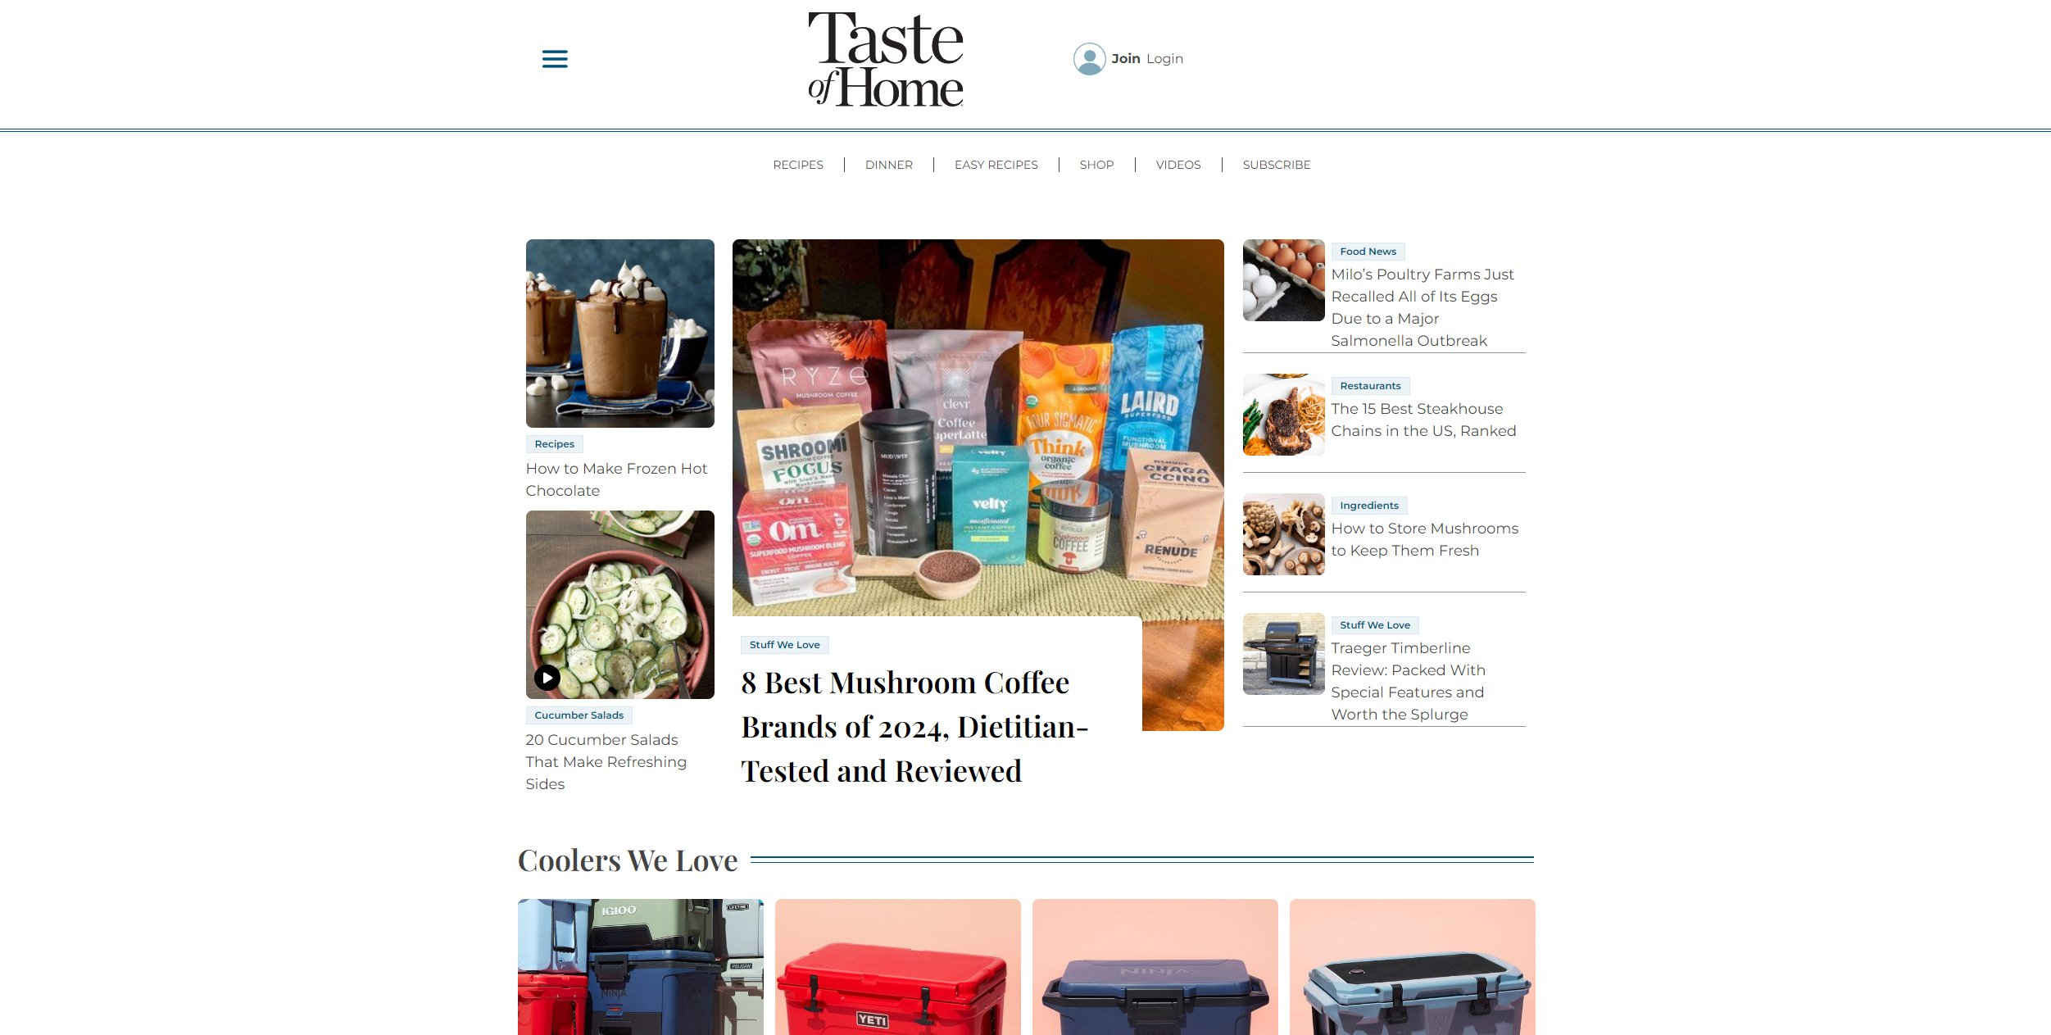
https://www.tasteofhome.com/

To be blunt, non of the recipe sites I found looked really appealing to me.
What I like is the use of different kinds of cards.
Trying to build something similar would probably take me weeks, as those applications are far more than just „recipe apps“. They are quite complex and offer some „social media“ features and sections for specific categories of recipes or something just food related, all of which influences their appearance.

